

**[DOCUMENT TITLE]**

**by:**

**[TITLE NAME SURNAME 12345678]**

**[SUBJECT]**

**BACHELOR OF ENGINEERING**

**In**

**COMPUTER AND ELECTRONIC ENGINEERING**

**North-West -University Potchefstroom Campus**

**[HANDED IN TO STUDY LEADER: TITLE INITIALS SURNAME]**

**2018**

# DECLARATION

I, **[NAME SURNAME]**, declare that this report is a presentation of my own original work.

Whenever contributions of others are involved, every effort was made to indicate this clearly, with due reference to the literature. No part of this work has been submitted in the past, or is being submitted, for a degree or examination at any other university or course.

Signed on this, [DATE OF SIGNING], in Potchefstroom.

A picture containing invertebrate, sitting

Description generated with high confidence

x____________________

[INITIALS SURNAME]

# TABLE OF CONTENTS

DECLARATION ii

TABLE OF CONTENTS iii

LIST OF FIGURES iv

LIST OF TABLES iv

1. INTRODUCTION 1

1.1 INTRO SUB 1 1

1.2 INTRO SUB 2 1

2. SECTION 2 2

2.1 SECTION 2 SUB 1 2

2.1.1 SECTION 2 SUB 1.1 2

2.1.2 SECTION 2 SUB 1.2 2

2.1.2.1 SECTION 2 SUB 1.2.1 2

2.1.2.2 SECTION 2 SUB 1.2.2 2

3. CONCLUSION AND RECOMMENDATIONS 3

3.1 CONCLUSION 3

3.2 RECOMMENDATIONS 3

# LIST OF FIGURES

Figure 1 : GENERIC PICTURE SHOWING SOMETHING 2

# 

# LIST OF TABLES

Table 1 : List of Abbreviations iv

Table : List of Abbreviations

|  |  |
| --- | --- |
| **Symbol or abbreviation** | **Meaning** |
|  |  |
|  |  |
|  |  |
|  |  |
|  |  |
|  |  |
|  |  |
|  |  |
|  |  |
|  |  |
|  |  |
|  |  |
|  |  |
|  |  |
|  |  |

## INTRODUCTION

### INTRO SUB 1

### INTRO SUB 2

## SECTION 2



### SECTION 2 SUB 1

### SECTION 2 SUB 1.1

### SECTION 2 SUB 1.2

### SECTION 2 SUB 1.2.1

### SECTION 2 SUB 1.2.2

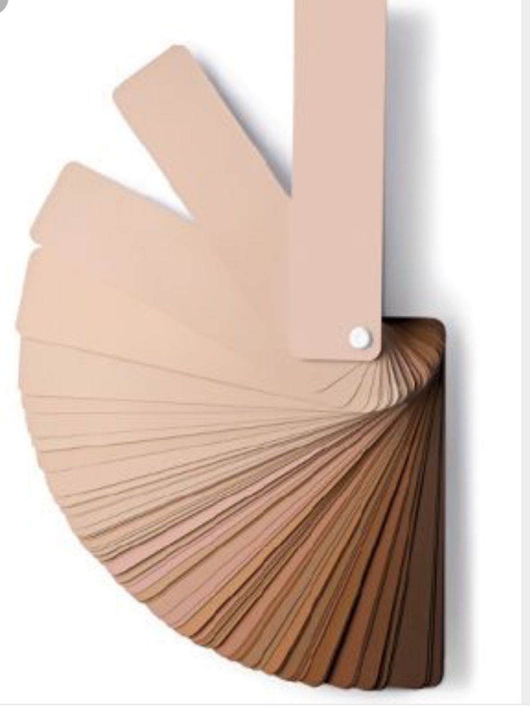

Figure : GENERIC PICTURE SHOWING SOMETHING

## CONCLUSION AND RECOMMENDATIONS



### CONCLUSION

### RECOMMENDATIONS

[WHEN FINISHING UP FINALISE THE COLOURS OF THE INDEX, UPDATE ALL FIELDS AND ENSURE DATE NAME AND STUDENT NUMBERS ARE CORRECT. ALSO ASSURE THAT ALL TEXT IS IN ARIAL 11 POINT TEXT WITH 1.5 LINE SPACING, ALL REFERENCES MUST BE DONE IN IEEE STYLE AND ADDED AT THE END OF THE DOCUMENT]